Tables and Figures – Bight 2023 SAV

QAQC checks
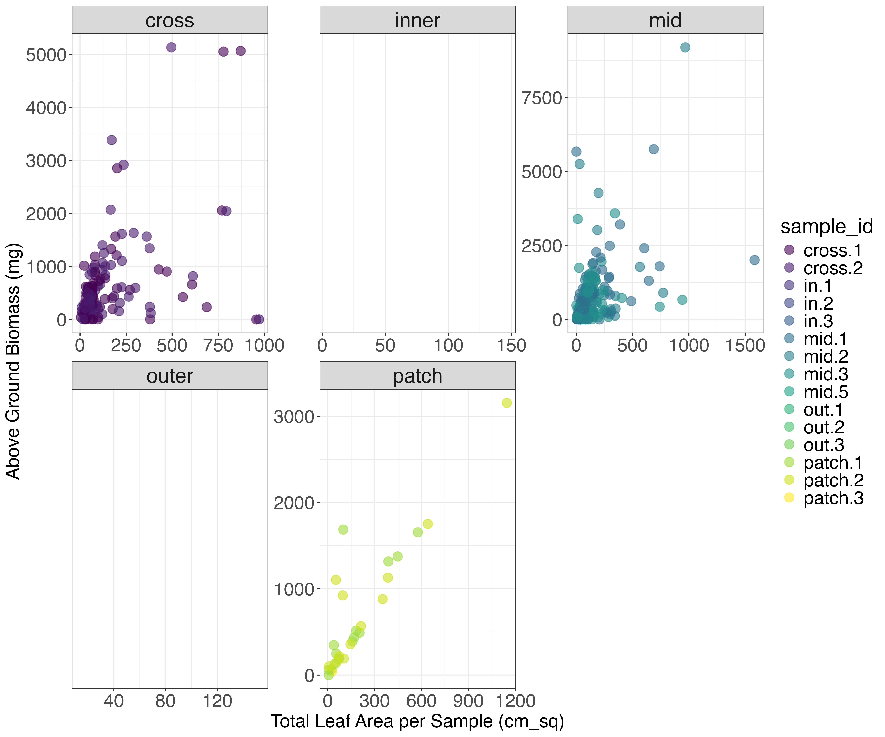Figure. Total leaf area (sum of all leaf areas per sample_id) vs above ground biomass measured. Data points missing from facets were leaf area measurements that did not have concurrent biomass measurements.

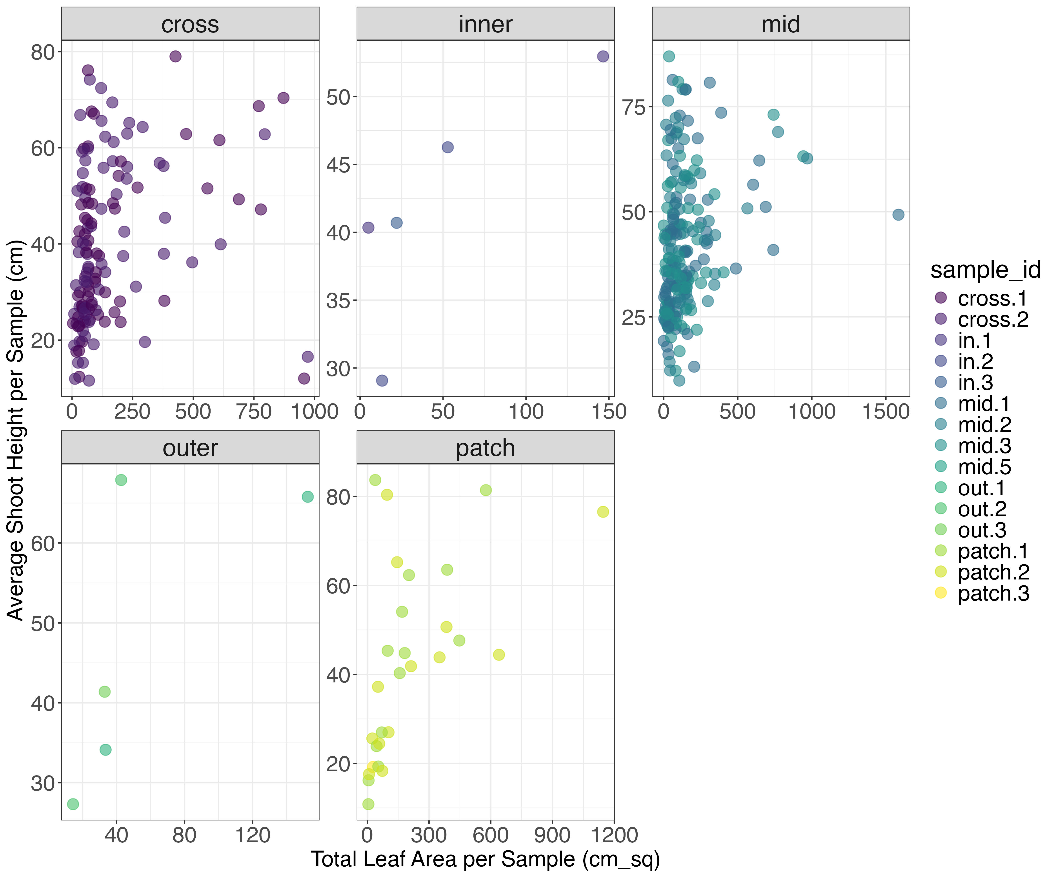Figure. Total leaf area (sum of all leaf area measurements per sample_id) vs. Average shoot height measured in each sample_id.

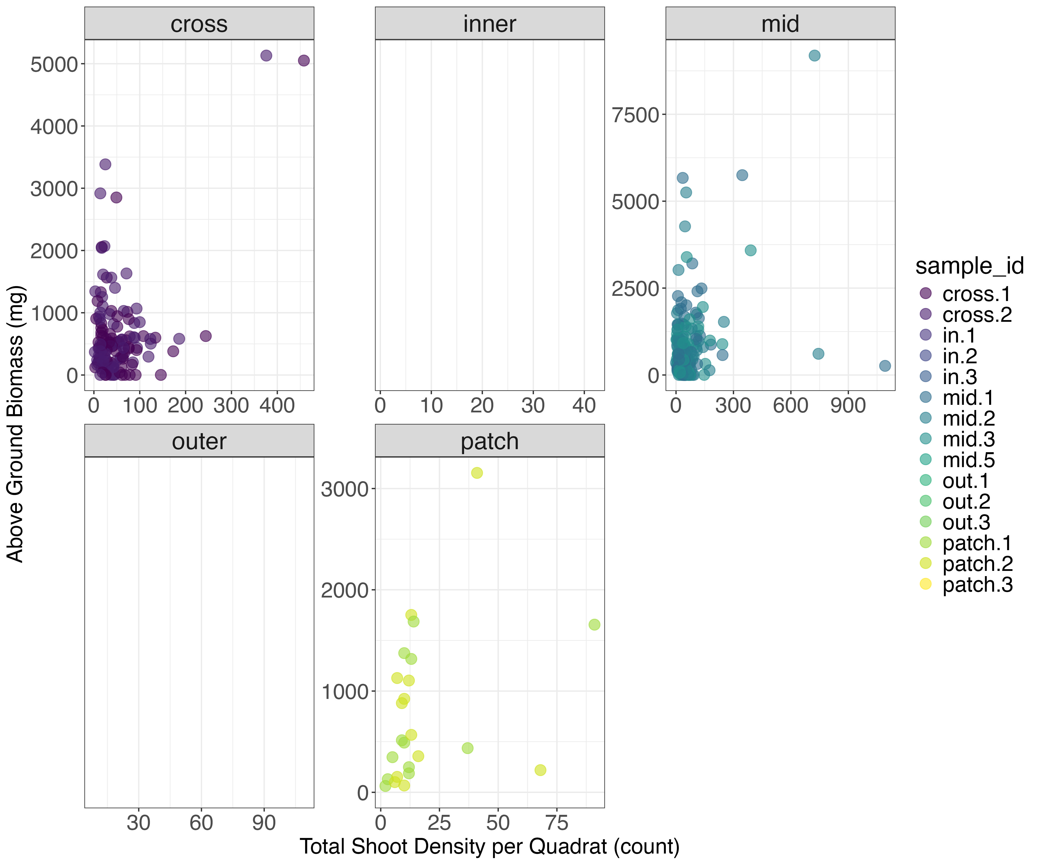Figure. Total shoot density per field quadrat vs above ground biomass per sample_id.

Structural Metrics Data
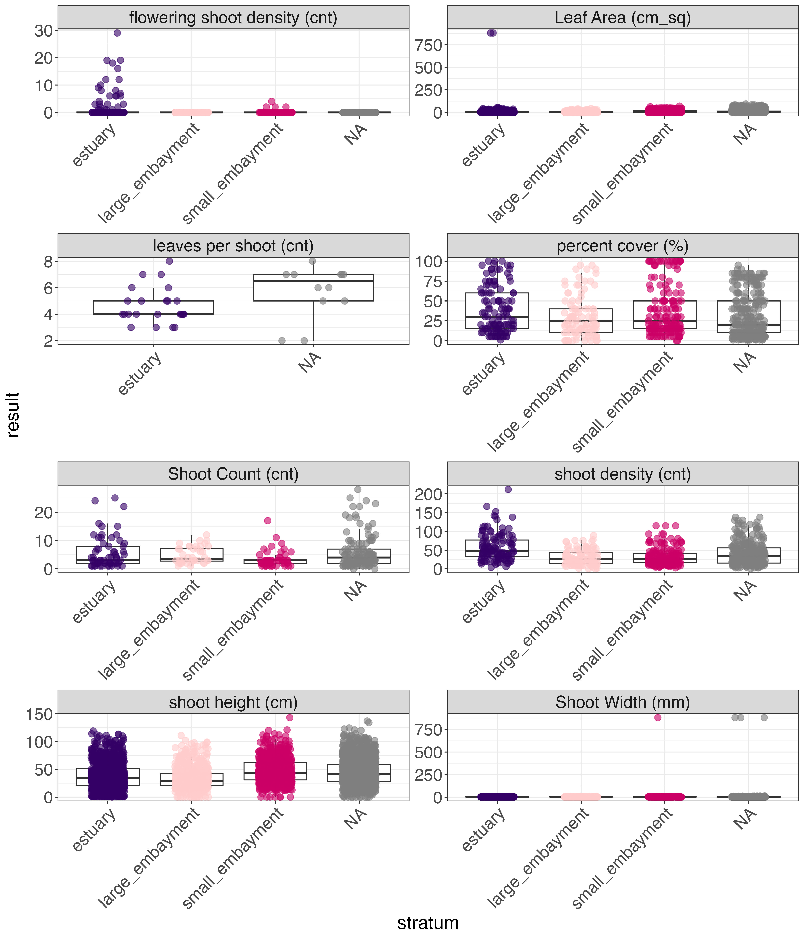
Figure. Eelgrass structural metrics measured in Bight 2023 survey.
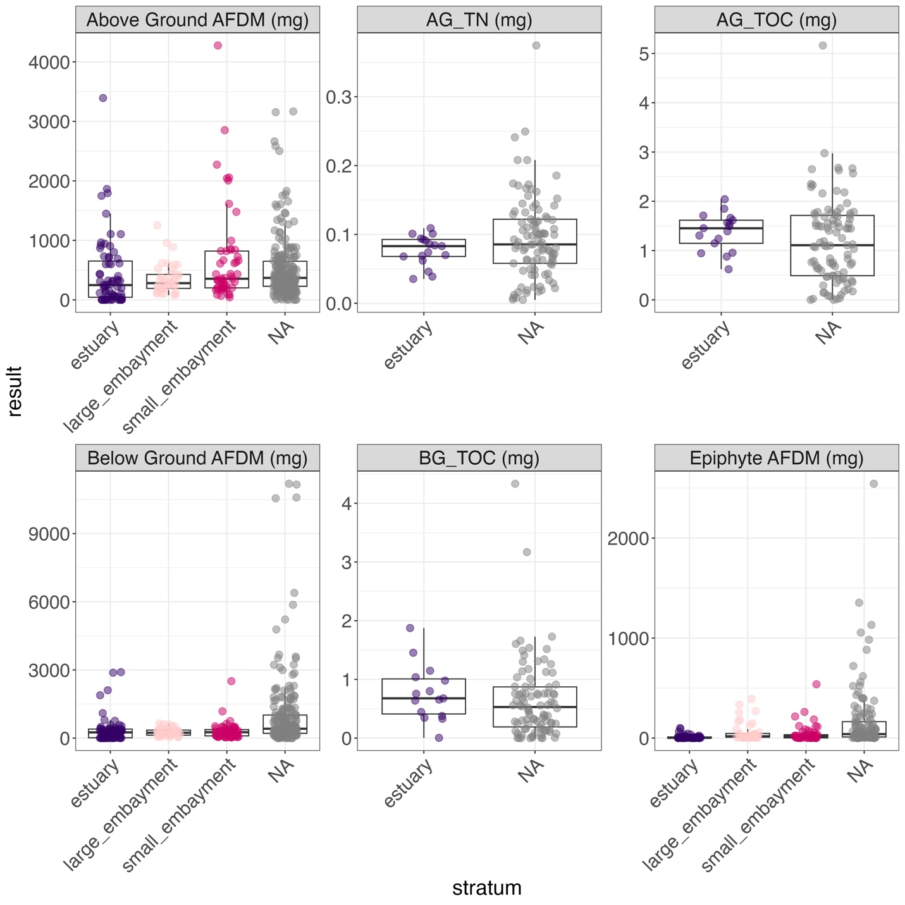Figure. Eelgrass structural metrics measured in the laboratory from the Bight 2023 survey

Interesting Relationships
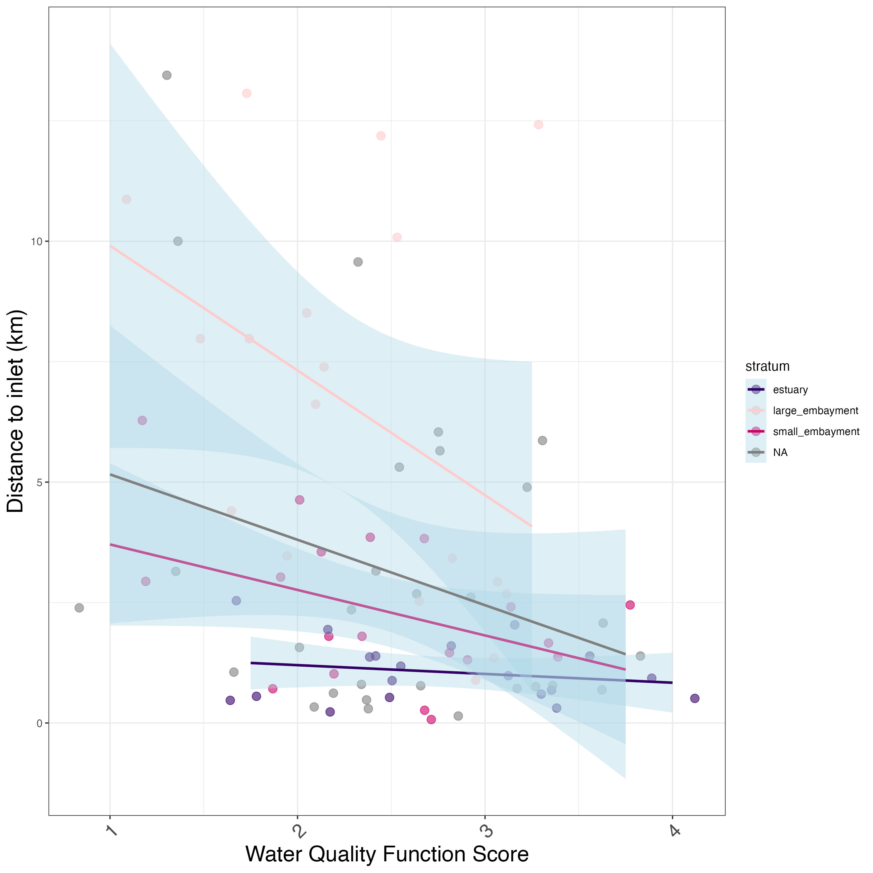Figure. Relationships between water quality ecosystem function and distance to inlet, by stratum.

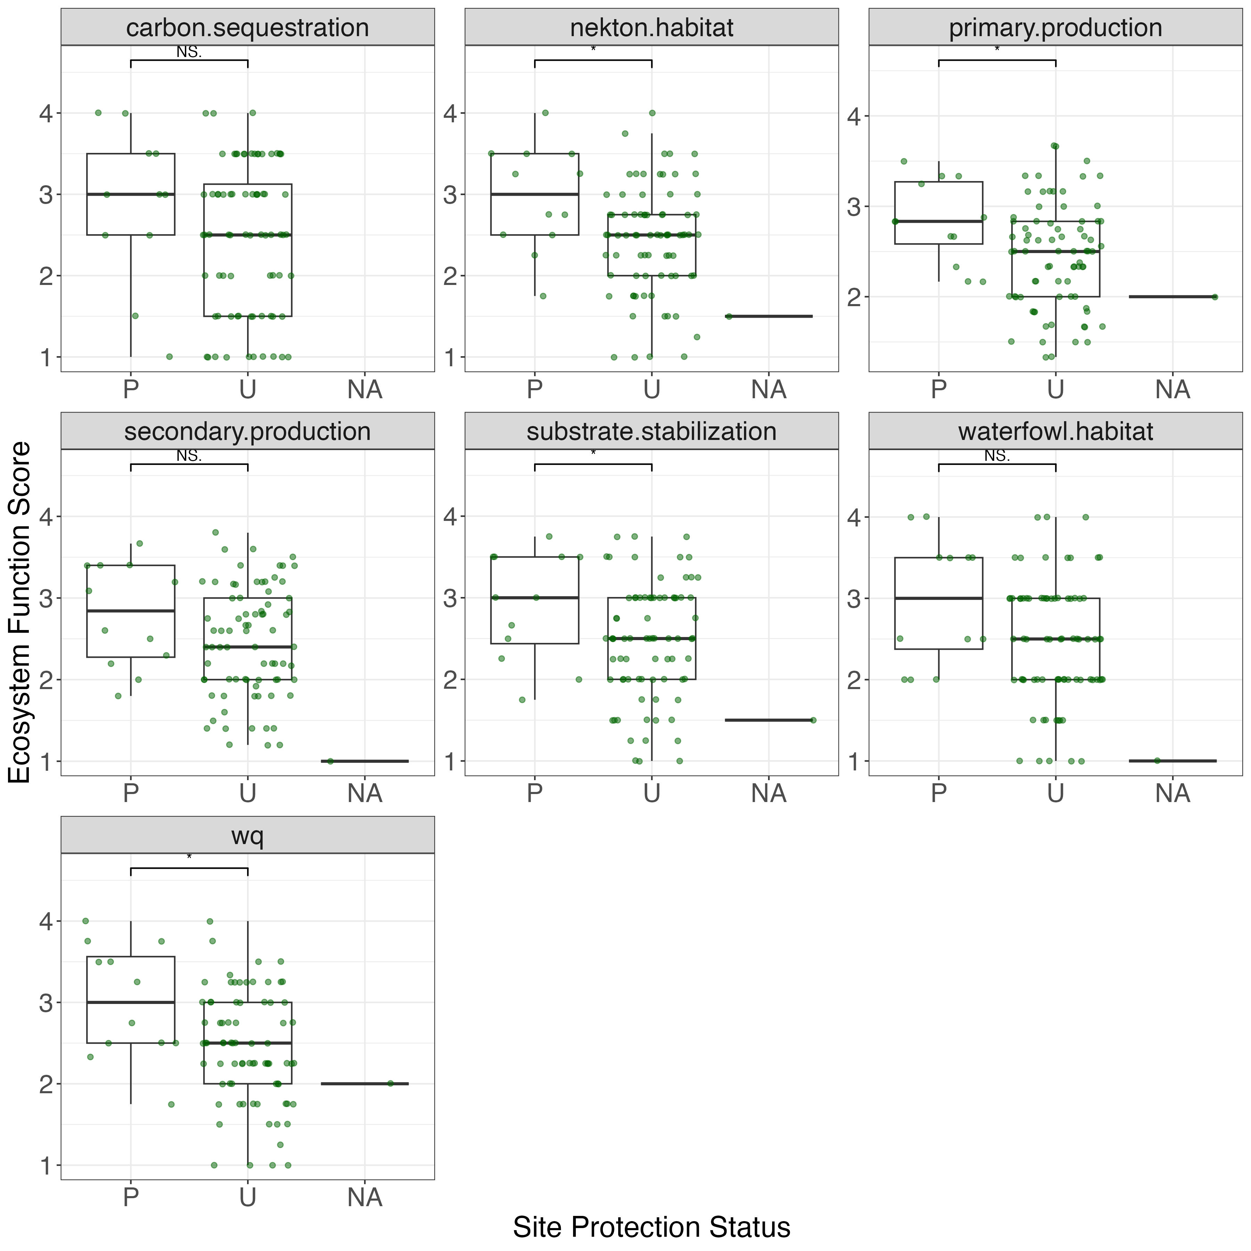Figure. Site protection status on ecosystem functions estimated using eelgrass. P = protected, U = unprotected.
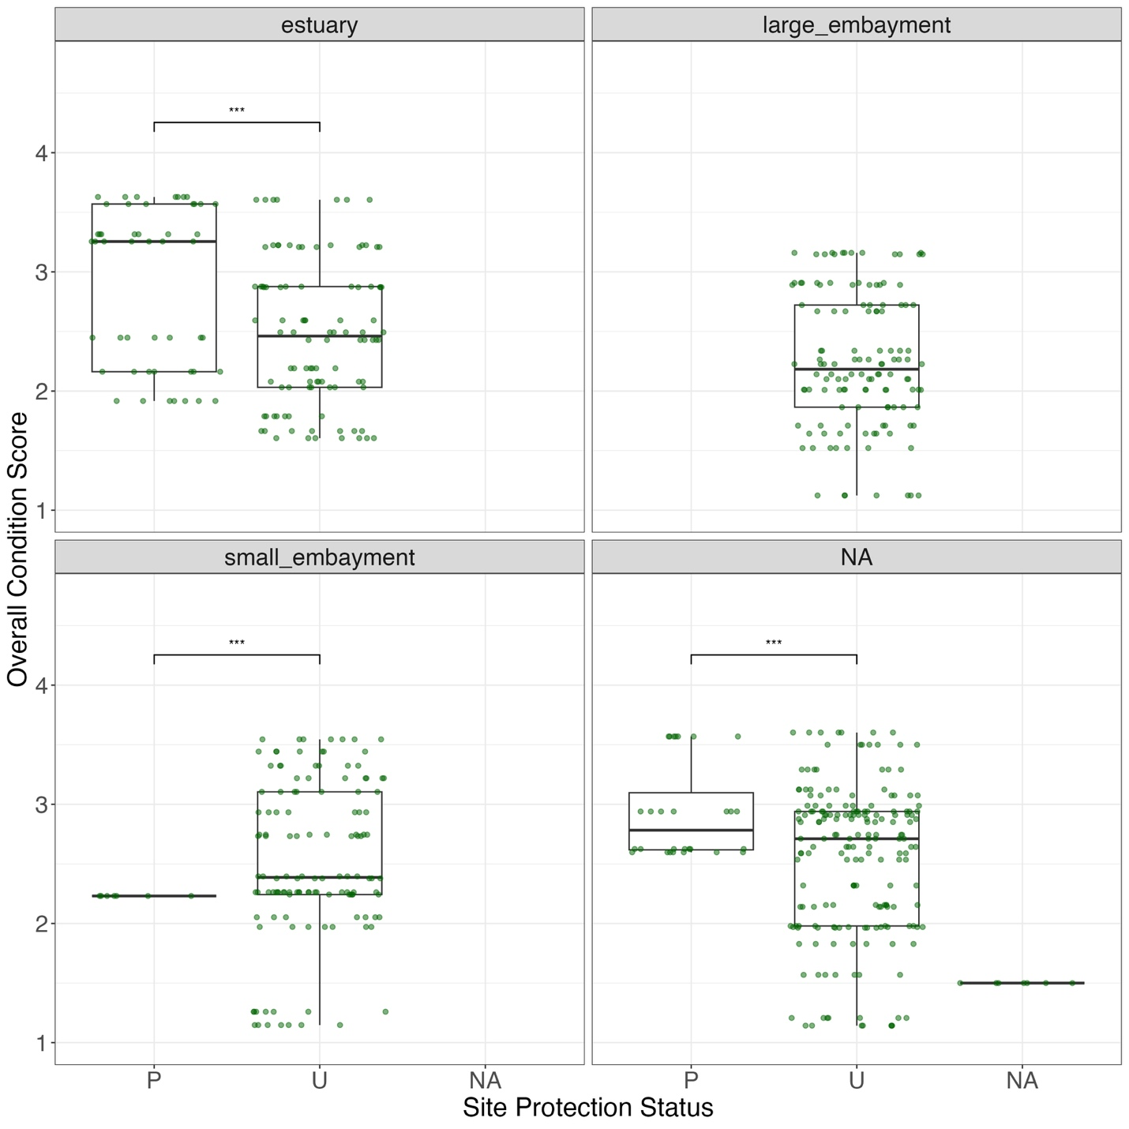
Figure. Overall eelgrass condition score and site protection status in each stratum. P = protected, U = unprotected.
Index figures

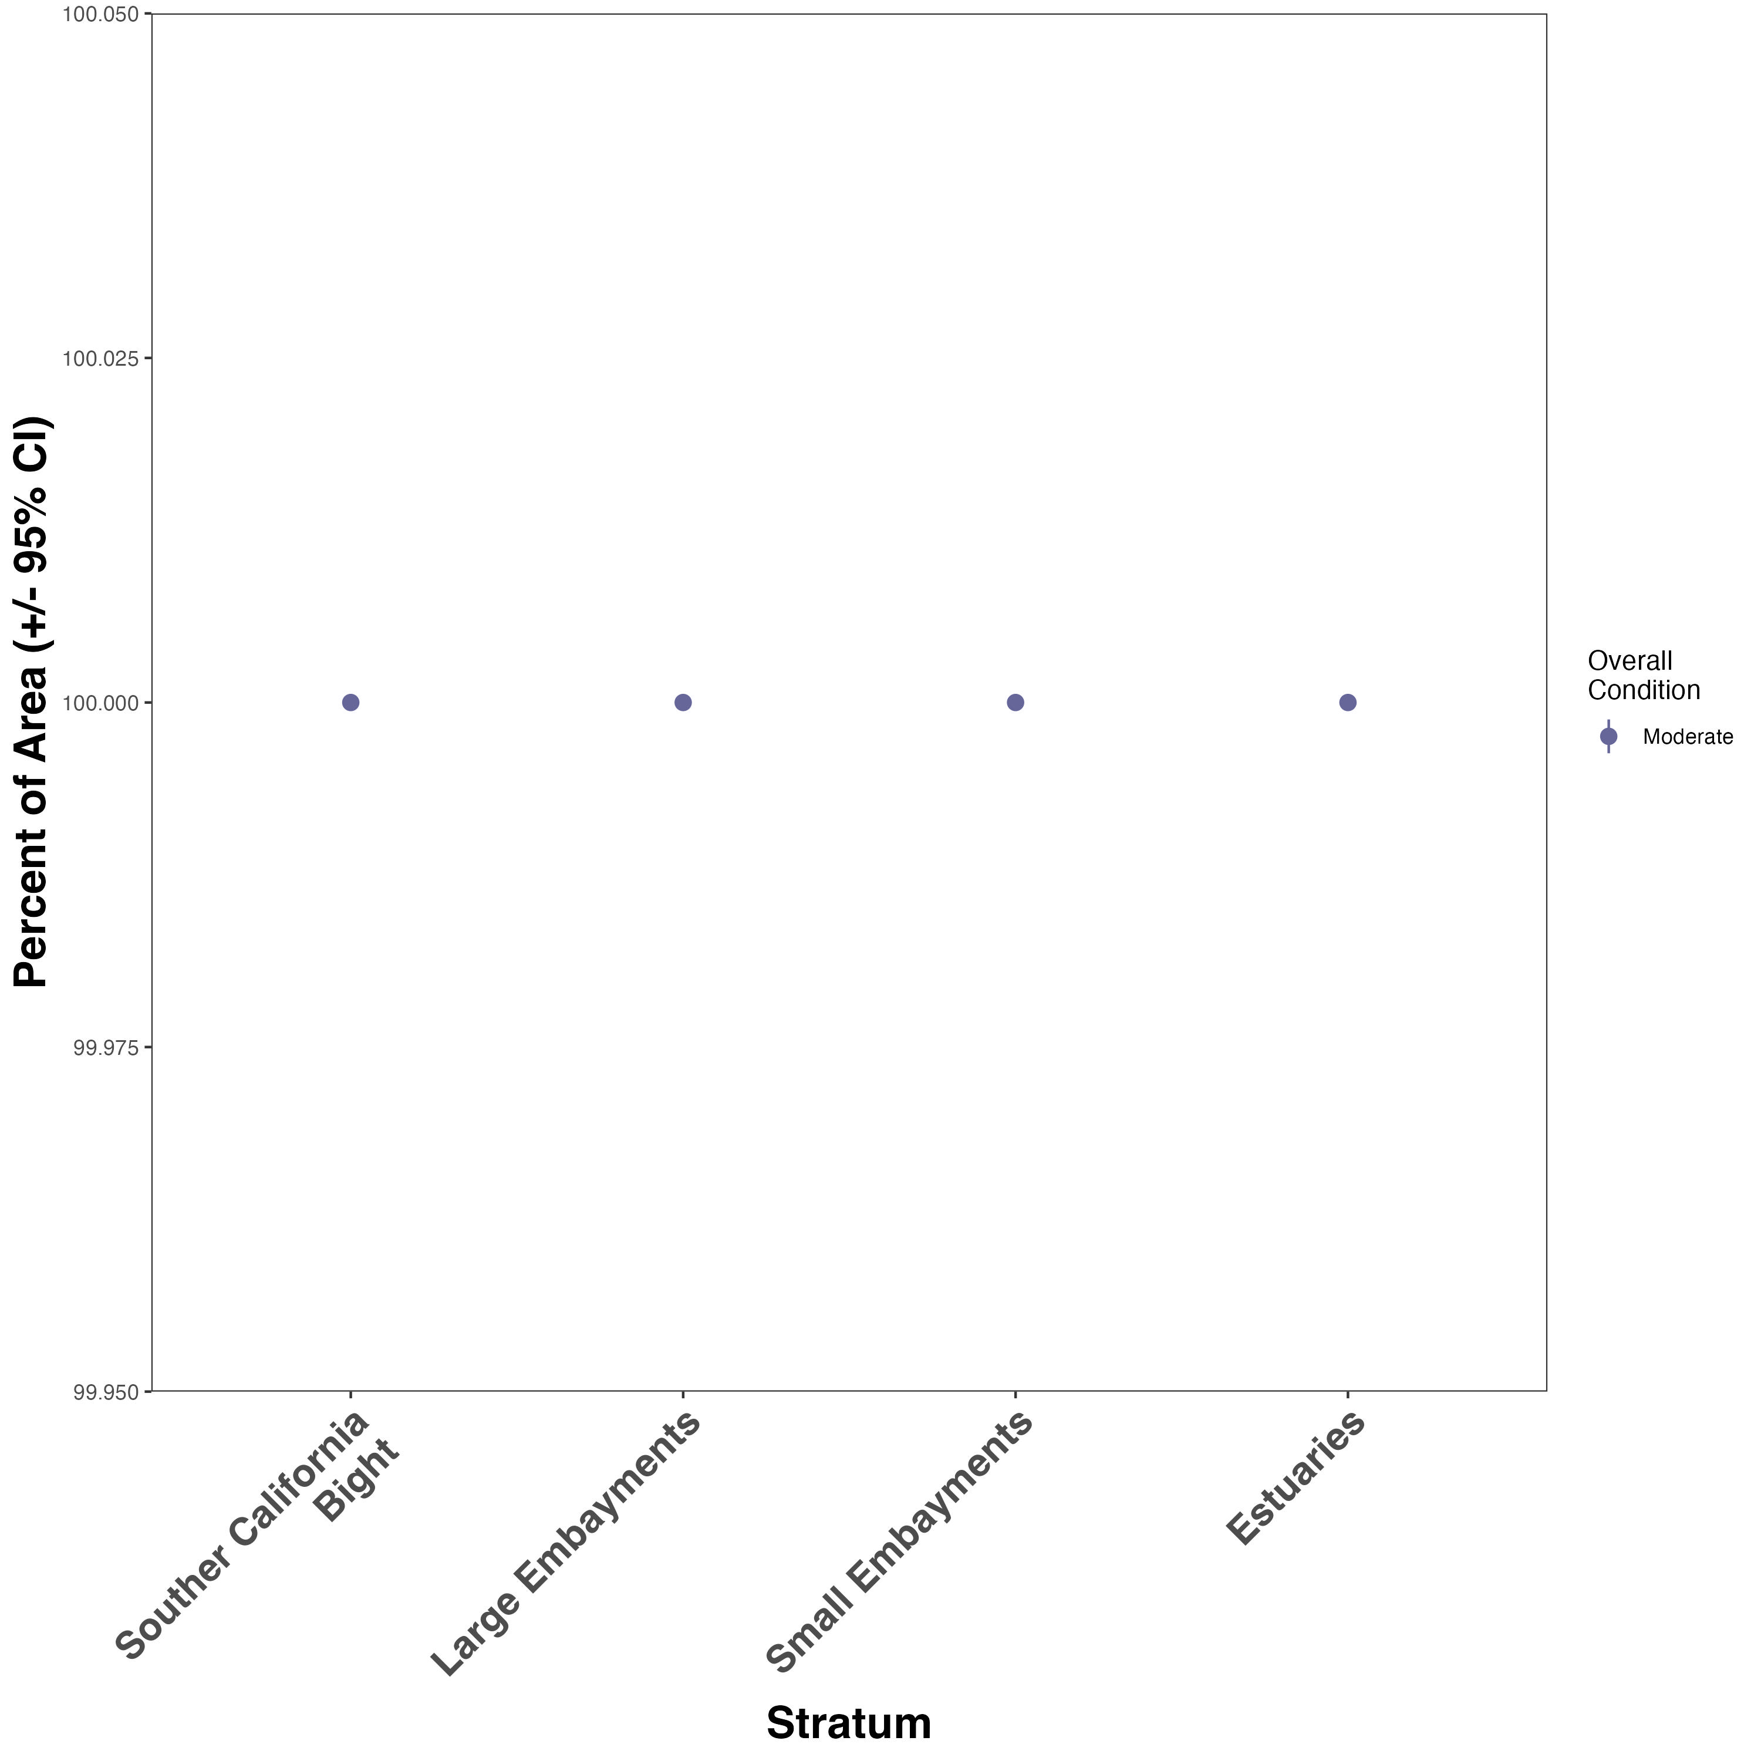Figure. Overall function scores

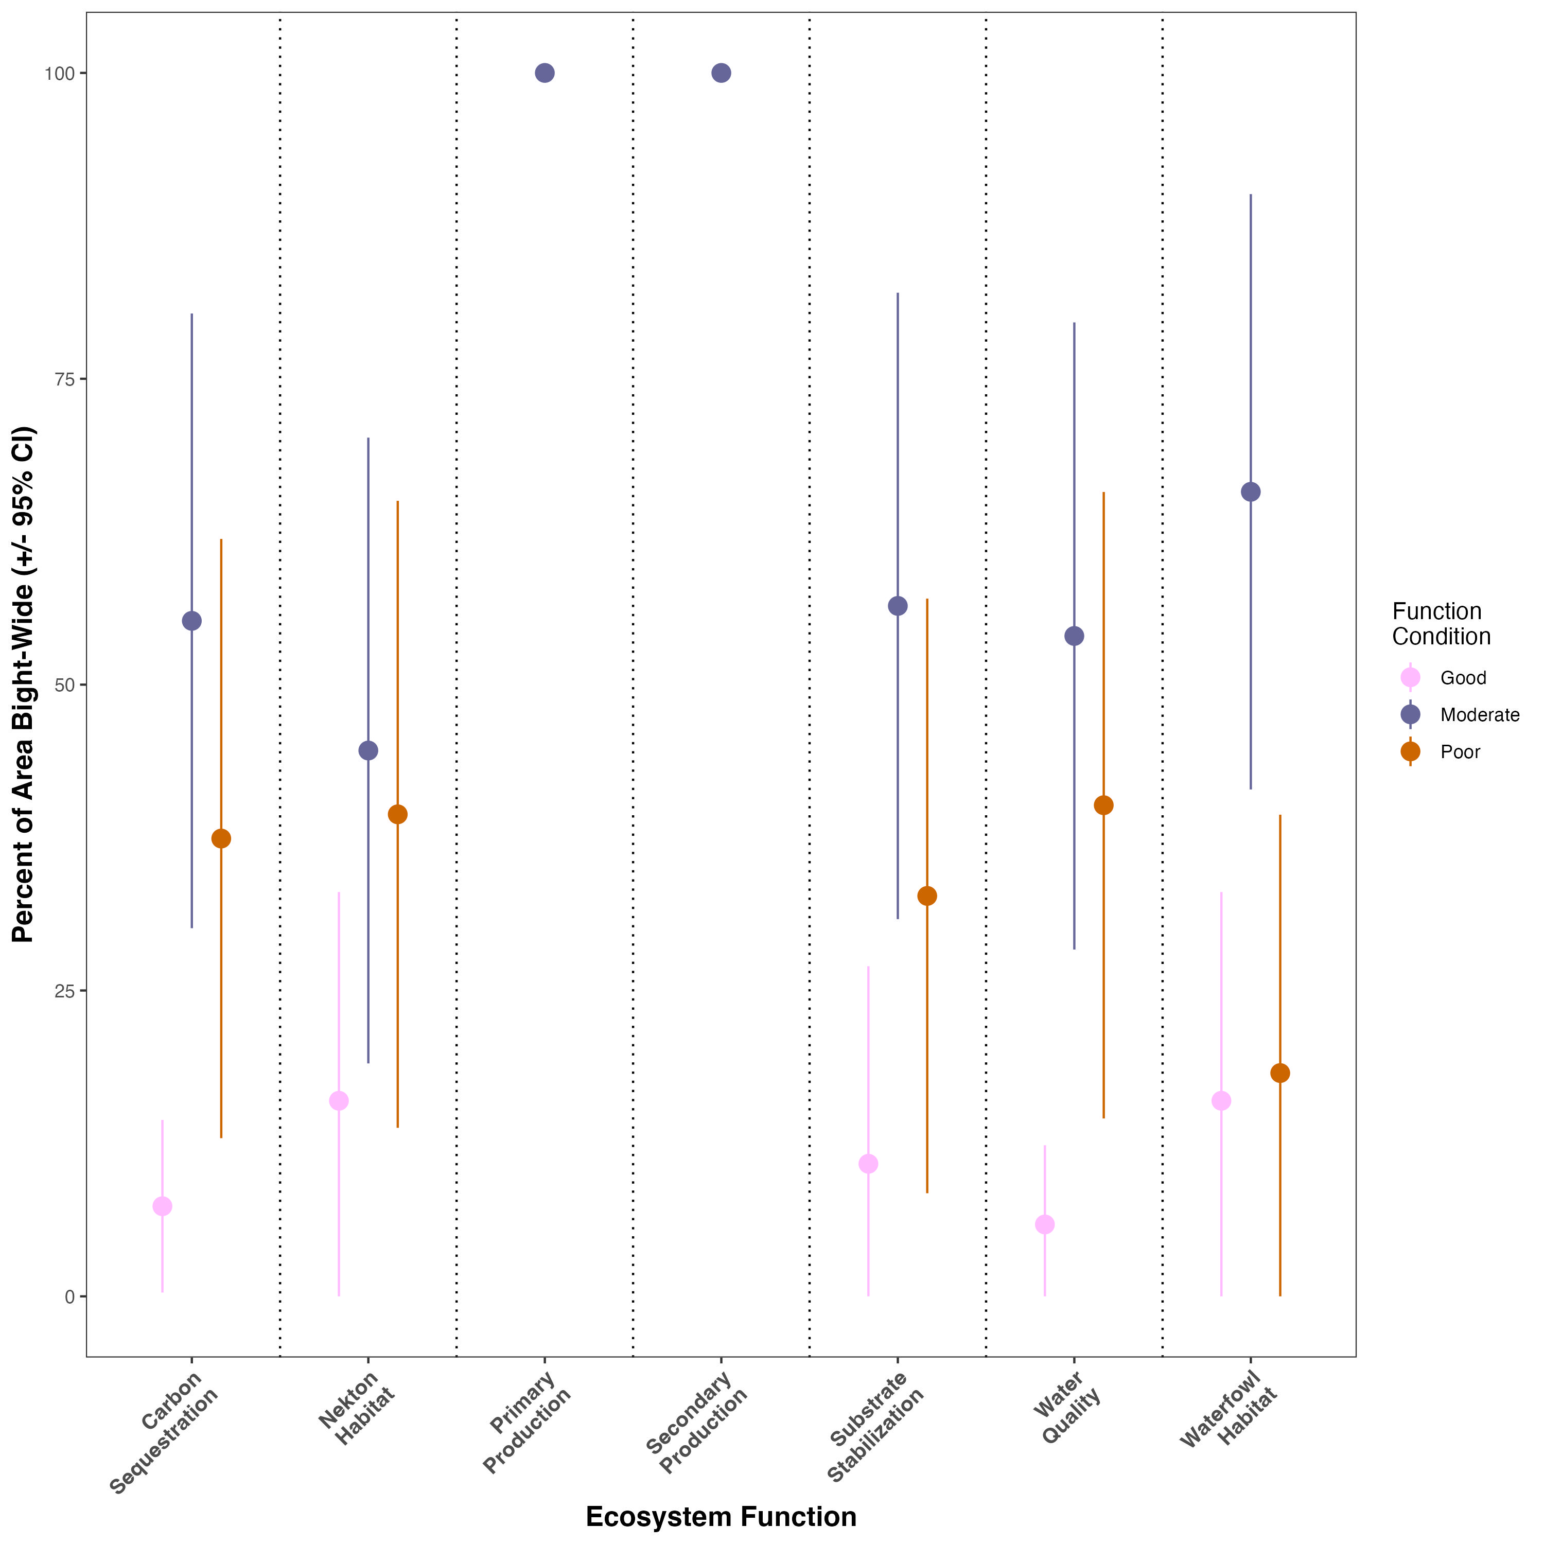
Figure. Area-weighted ecosystem function condition for Bight-wide eelgrass survey

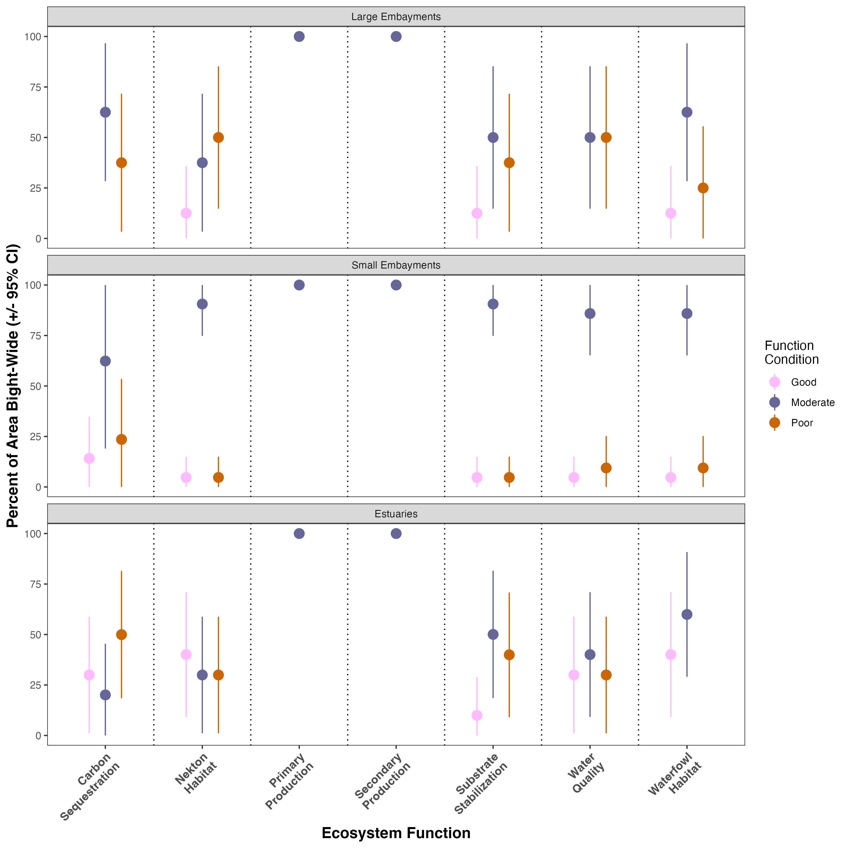
Tables for the Appendix

Table. Ecosystem function estimated by each stratum. Mean function scores < 2 are considered poor condition, and <3 are considered good condition.
Stratum | Ecosystem function | Mean | Sd | Min | Max | Range | Condition
estuary | carbon.sequestration | 2.25 | 1.161 | 1 | 3.5 | 2.5 | moderate condition
estuary | nekton.habitat | 2.545 | 0.65 | 1.75 | 3.25 | 1.5 | moderate condition
estuary | primary.production | 2.337 | 0.427 | 1.67 | 2.88 | 1.21 | moderate condition
estuary | secondary.production | 2.408 | 0.815 | 1.4 | 3.5 | 2.1 | moderate condition
estuary | substrate.stabilization | 2.424 | 0.756 | 1.5 | 3.75 | 2.25 | moderate condition
estuary | waterfowl.habitat | 2.773 | 0.684 | 2 | 3.5 | 1.5 | moderate condition
estuary | wq | 2.598 | 0.691 | 1.75 | 3.5 | 1.75 | moderate condition
large_embayment | carbon.sequestration | 2.125 | 0.694 | 1 | 3 | 2 | moderate condition
large_embayment | nekton.habitat | 2 | 0.567 | 1.5 | 3.25 | 1.75 | moderate condition
large_embayment | primary.production | 2.146 | 0.431 | 1.5 | 2.83 | 1.33 | moderate condition
large_embayment | secondary.production | 2.25 | 0.542 | 1.4 | 3.2 | 1.8 | moderate condition
large_embayment | substrate.stabilization | 1.969 | 0.619 | 1.25 | 3.25 | 2 | poor condition
large_embayment | waterfowl.habitat | 2.125 | 0.641 | 1.5 | 3.5 | 2 | moderate condition
large_embayment | wq | 2.062 | 0.496 | 1.5 | 3 | 1.5 | moderate condition
small_embayment | carbon.sequestration | 2.208 | 1.054 | 1 | 4 | 3 | moderate condition
small_embayment | nekton.habitat | 2.479 | 0.538 | 1.25 | 3.5 | 2.25 | moderate condition
small_embayment | primary.production | 2.222 | 0.641 | 1.33 | 3.33 | 2 | moderate condition
small_embayment | secondary.production | 2.35 | 0.678 | 1.2 | 3.4 | 2.2 | moderate condition
small_embayment | substrate.stabilization | 2.417 | 0.625 | 1 | 3.5 | 2.5 | moderate condition
small_embayment | waterfowl.habitat | 2.583 | 0.764 | 1 | 3.5 | 2.5 | moderate condition
small_embayment | wq | 2.312 | 0.604 | 1.25 | 3.75 | 2.5 | moderate condition
NA | carbon.sequestration | 2.776 | 0.786 | 1 | 4 | 3 | moderate condition
NA | nekton.habitat | 2.467 | 0.688 | 1 | 3.75 | 2.75 | moderate condition
NA | primary.production | 2.507 | 0.544 | 1.33 | 3.67 | 2.34 | moderate condition
NA | secondary.production | 2.641 | 0.643 | 1.2 | 3.8 | 2.6 | moderate condition
NA | substrate.stabilization | 2.675 | 0.743 | 1 | 3.75 | 2.75 | moderate condition
NA | waterfowl.habitat | 2.5 | 0.809 | 1 | 4 | 3 | moderate condition
NA | wq | 2.428 | 0.682 | 1 | 3.5 | 2.5 | moderate condition

Table. Overall eelgrass condition by waterbody. Overall condition scores < 2 are considered poor condition, and <3 are considered good condition.
waterbody | mean | sd | min | max | range | overall condition
Agua Hedionda Lagoon | 3.082 | 0.147 | 2.94 | 3.22 | 0.28 | good condition
Alamitos Bay | 1.731 | 0.412 | 1.21 | 2.32 | 1.11 | poor condition
Batiquitos Lagoon | 2.989 | 0.35 | 2.45 | 3.32 | 0.87 | moderate condition
Bolsa Chica | 1.917 | 0 | 1.92 | 1.92 | 0 | poor condition
Dana Point Harbor | 2.243 | 0 | 2.24 | 2.24 | 0 | moderate condition
Huntington - Magnolia Marsh2 | 2.262 | 0 | 2.26 | 2.26 | 0 | moderate condition
King Harbor | 2.155 | 0 | 2.15 | 2.15 | 0 | moderate condition
La Jolla Cove | 2.598 | 0 | 2.6 | 2.6 | 0 | moderate condition
Magnolia Marsh | 2.904 | 0.666 | 2.26 | 3.55 | 1.29 | moderate condition
Mission Bay | 2.96 | 0.51 | 1.98 | 3.6 | 1.62 | moderate condition
Newport Bay | 1.944 | 0.266 | 1.52 | 2.23 | 0.71 | poor condition
Oceanside Harbor | 2.91 | 0 | 2.91 | 2.91 | 0 | moderate condition
Port of Los Angeles | 2.395 | 0.78 | 1.15 | 3.1 | 1.95 | moderate condition
San Diego Bay | 2.462 | 0.48 | 1.64 | 3.07 | 1.43 | moderate condition
San Diego Bay (Zuniga Jetty) | 3.124 | 0 | 3.12 | 3.12 | 0 | good condition
San Diego Estuary | 1.788 | 0 | 1.79 | 1.79 | 0 | poor condition
San Diego South Bay | 2.138 | 0.107 | 2.01 | 2.26 | 0.25 | moderate condition
San Dieguito Lagoon | 3.208 | 0 | 3.21 | 3.21 | 0 | good condition
San Elijo Lagoon | 1.143 | 0 | 1.14 | 1.14 | 0 | poor condition
Santa Ana River | 1.605 | 0 | 1.6 | 1.6 | 0 | poor condition
Santa Cruz Island | 2.625 | 0 | 2.62 | 2.62 | 0 | moderate condition
Seal Beach NWR | 2.477 | 0.414 | 2.08 | 2.88 | 0.8 | moderate condition
Seal Beach NWR (Case Pond) | 1.664 | 0 | 1.66 | 1.66 | 0 | poor condition

